**Cisco**

[**300-180**](https://www.marks4sure.com/300-180-exam.html)

**Troubleshooting Cisco Data Center Infrastructure**

## Version: 17.0



Web: [www.marks4sure.com](https://www.marks4sure.com/) Email: [support@marks4sure.com](mailto:support@marks4sure.com)

## [ Total Questions: 197]

**IMPORTANT NOTICE**

**Feedback**

We have developed quality product and state-of-art service to ensure our customers interest. If you have any suggestions, please feel free to contact us at [feedback@marks4sure.com](mailto:feedback@marks4sure.com)

**Support**

If you have any questions about our product, please provide the following items: exam code



screenshot of the question login id/email

please contact us at [support@marks4sure.com](mailto:support@marks4sure.com) and our technical experts will provide support within 24 hours.

**Copyright**

The product of each order has its own encryption code, so you should use it independently. Any unauthorized changes will inflict legal punishment. We reserve the right of final explanation for this statement.

Practice Test

Cisco - 300-180



Question #:1

A customer reports that it cannot establish a vPC peer link between two Cisco Nexus 5548UP Switches. The interfaces on both switches are configured and cabled correctly. The interface status is up/down on switch 1 and up/up on switch 2. Which three steps are taken to isolate the root cause? (Choose three.)

1. ask the customer if the link was ever functional
2. determine whether the fiber-optic cable type (single mode or multimode) matches the X2 modules
3. swap the fiber-optic cable with one known to be good
4. swap the transceivers between the two interfaces
5. swap the ends of the fiber-optic cable

## Answer: C D E

Question #:2

You receive a priority 1 trouble ticket that there is OSPF route instability in the data center core Cisco Nexus 7018 Switches. Which command is useful to help validate a theory that hello packets are being throttled?

1. N7018# show class-map interface control-plane
2. N7018# show policy-map interface control-plane
3. N7018# show service-policy interface control-plane
4. N7018# show copp status
5. N7018# show copp statistics
6. N7018# show control-plane class copp-system-class-critical

## Answer: B

Question #:3

Refer to the exhibit.

Practice Test

Cisco - 300-180

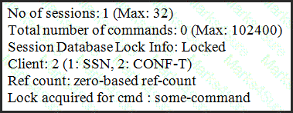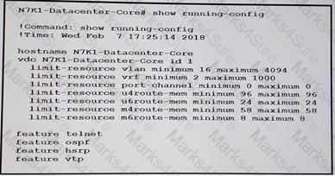

What is the cause of the ISSU failure when using the command show system internal csm global info?

1. The command conf-t is holding a lock and not released it.
2. The SSN feature is not enabled on both switches.
3. The reference count is less than 1 due to a lack of successful config-sync.
4. It cannot be determined from the output.
5. An Administrator is logged in on another session and has a lock of the session data base to prevent ISSU.

## Answer: A

Question #:4

Refer to the exhibit.

You cannot create a layer 3 port channel interface on the Cisco nexus 7000 Series switch to aggregate two links connected to the core switch. Which reason is the root cause of this problem?

1. No unicast IPv4 rout memory resource are available.
2. No port channel resources are available,.
3. No multicast IPv4 rout memory resources are available.

Practice Test

Cisco - 300-180



1. Layer 3 port channel cannot be configured on Cisco Nexus 7000 Series switches, instead interface VLAN must configured and port channel must be mapped to it.

## Answer: B

Question #:5

A customer is deploying FCoE in its network and has found that the connected host does not support FIP. Which command will be useful in troubleshooting this issue?

1. show platform fcoe_mgr info interface vfc id
2. show platform fcoe_mgr info software interface vfc id
3. show platform software fcoe_mgr info interface vfc id
4. show platform software interface fcoe_mgr info vfc id

## Answer: C

Question #:6

After removing a VMM domain from an EPG, you discover that the associated virtual port groups remain in the VMware vCenter configuration. What causes the virtual port groups to persist in the configuration?

1. The MAC addresses that are learned by the ports of the spine switches are incorrect.
2. The port groups are being used by a virtual machine network adapter.
3. The MAC addresses that are learned by the ports of the leaf switches are incorrect
4. There is a mismatch between the data center name in vCenter and the VMM controller policy.

## Answer: B

Question #:7

Which two protocols are important for DCBX to enable the 'no drop' classes that are needed for lossless transmission? (Choose Two.)

1. PFC
2. LACP
3. FIP
4. LLDP
5. ETS

Practice Test

Cisco - 300-180



## Answer: A E

Question #:8

Which two of the following describe the correct requirements for non-disruptive ISSU on Cisco Nexus 7000 Series Switches? (Choose two.)

1. updated kickstart and system images may be staged in bootflash on single-supervisor switches
2. updated kickstart and system images may be staged in bootflash on dual-supervisor switches
3. updated kickstart and system images may be staged remotely on single-supervisor switches
4. dual supervisors
5. clock synchronization

## Answer: A D

Question #:9

Refer to the exhibit.

Practice Test

Cisco - 300-180

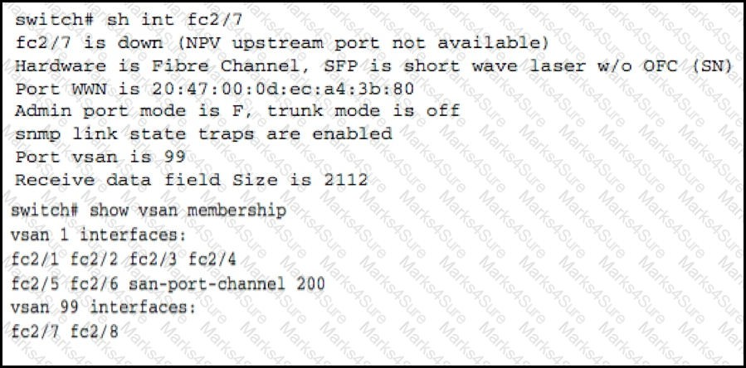

The server port connected to the NPV edge switch does not come online. Which action should fix the problem?

1. Move the NP ports on the NPV edge and the F ports on the NPIV into the same VSAN 99.
2. Move the NP ports on the NPV edge and the F ports on the NPIV in the default VSAN 1.
3. Move all the ports into VLAN 1.
4. Move all the ports into VSAN 99.
5. Move all the ports into VLAN 99.

## Answer: A

Question #:10

In Cisco UCS, which logs are used to troubleshoot hardware failure?

1. system event log
2. audit log

Practice Test

Cisco - 300-180

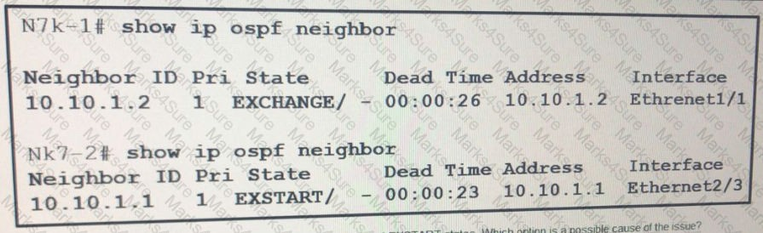

1. gateway logs
2. system log

## Answer: A

Question #:11

In a Cisco Data center network, what troubleshooting step would you do first when having a npv issue?

1. Check to see if npv is enabled
2. Check name server database to see if it recognizes device
3. Check detail config of FCNS database
4. Check the show-tech-support detail

## Answer: A

Question #:12

Refer to the exhibit. The two switches are stuck in the EXCHANGE and EXSTART states. Which option is a possible cause of the issue?

1. The subnet mask is mismatched.
2. The interfaces are not connected.
3. The MTU is mismatched.
4. The IP address of the OSPF process is incorrect.

Practice Test

Cisco - 300-180

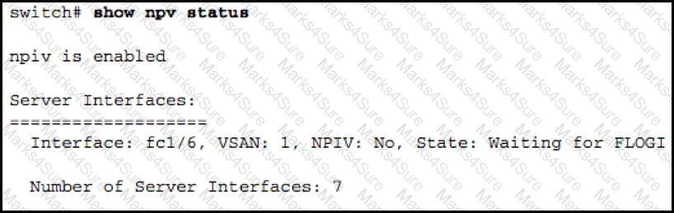

## Answer: D

Question #:13

On the secondary vPC switch, under which circumstance does the vPC autorecovery feature not bring up the vPC member ports?

1. Peer link fails, and subsequently, the peer-keepalive link fails.
2. Peer link is up, and the peer-keepalive link fails.
3. Both vPC peers are reloaded, and the primary does not come back up.
4. Peer link fails, and subsequently, the primary switch fails.

## Answer: B

Question #:14

Refer to the exhibit.

Customer encounters the problem as shown in the exhibit. What is the cause of the problem?

1. No server was requested or received by the FLOGI database.
2. One external link must be up for server interface to be up.
3. Multiple external links must be up for the server to come up.
4. Internal links are down and must be up for the server interface to be up.

Practice Test

Cisco - 300-180



## Answer: A

Question #:15

When you look at the HSRP state for devices on a VLAN that is extended by OTV, you see the following states: Active, Standby, and Listen. However, you intended each data center device to show the state as Active and Standby. What is the problem?

1. HSRP is not configured correctly.
2. A VACL is missing.
3. A PACL is missing.
4. This cannot be done.

## Answer: B

Question #:16

What are the minimum number and maximum number of members that a SAN PortChannel can have?

A. 1, 16

B. 2, 16

C. 1, 32

D. 2, 32

1. 1 minimum with no maximum
2. 2 minimum with no maximum

## Answer: A

Question #:17

Refer to the exhibit.

Practice Test

Cisco - 300-180

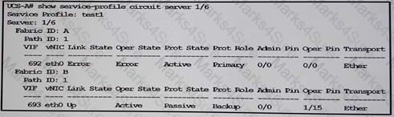

You have fabric interconnects. You discover that all traffic flows through a fabric interconnect named fabric-interconnect B.

Which of the following could cause the issue?

1. An administrator evacuated fabric-interconnect A.
2. There is a version mismatch between the fabric interconnects.
3. An administrator assigned an invalid OOBP IP address to fabric-interconnect B.
4. the fabric interconnects have duplicate IP address.

## Answer: A

Question #:18

Your customer has a dual Cisco Nexus 7010 Switches in its data center. Customer's representatives want to know how to determine if Cisco IOS ISSU is possible on the switches as they are upgrading to version 6.0.4. Which command is useful to determine if the upgrade will be non-disruptive?

1. N7010-C1# show system redundancy ha status
2. N7010-C1# show incompatibility system
3. N7010-C1# install all
4. N7010-C1# show issu test bootflash:n7000-s1-system.6.0.4.bin

## Answer: C

Question #:19

Refer to the exhibit.

Practice Test

Cisco - 300-180

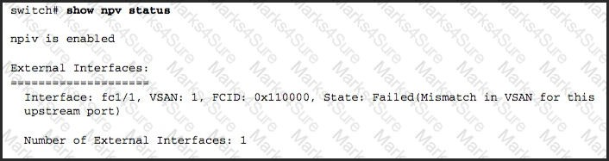

When suspending or deleting VSANs, which three statements are true? (Choose three.)

1. You can delete only one VSAN at a time.
2. You must wait 60 seconds after you enter the vsan suspend command before you enter another command.
3. You must wait 120 seconds after you enter the vsan suspend command before you enter another command.
4. You can unsuspend only one VSAN at a time.
5. You can delete multiple VSANs as long as they are in the same domain.
6. You can delete multiple VSANs as long as they are in the same zone.

## Answer: A B D

Question #:20

Which statement would explain why the overlay interface on an OTV edge device is not in the up state?

1. The site identifiers are identical within a multihomed site.
2. Multicast groups are not mapped to a range of SSM addresses to carry the multicast traffic.
3. An adjacency server is not configured for connectivity over a multicast transport.
4. The OTV IS-IS metrics do not match across all adjacent OTV edge devices.

## Answer: B

Question #:21

You must identify and isolate traffic loss. Which option do you configure to monitor EPG-to-EPG traffic

Practice Test

Cisco - 300-180

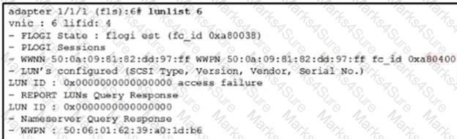

within a tenant?

1. SPAN
2. traffic map
3. tcpdump
4. atomic counters

## Answer: C

Question #:22

Refer to the exhibit.

You have a server that fails to boot *which option is a possible cause of the issue?

1. an incorrect boot policy
2. incorrect zoning
3. an incorrect FC/FCoE target port in the SAN
4. incorrect LUN masking on the Storage array

## Answer: D

Question #:23

A customer is configuring an upstream disjoint Layer 2 network in a Cisco UCS domain. So far they have configured the following:

Fabric Interconnects are in switching mode.

Practice Test

Cisco - 300-180



There is symmetrical configuration for high availability. There are no overlapping VLANs.

Each vNIC is communicating with one disjoint Layer 2 network.

After validating the above, the customer is still having issues with network connectivity. What is the issue?

1. Overlapping VLANs are allowed in a disjoint Layer 2 network.
2. The vNIC configuration is incorrect and must communicate with two or more disjoint layer 2 networks.
3. The fabric interconnect must be in end-host mode for a disjoint Layer 2 network.
4. Asymmetrical configuration for high availability needs to be configured.

## Answer: C

Question #:24

You are no longer seeing updates to the device-aliases database on your Cisco Nexus 5596UP Switch. Which command is useful to determine if the scope of Cisco Fabric Services application distribution was being administratively limited?

1. N5K2# show cfs region
2. N5K2# show cfs scope
3. N5K2# show cfs locale
4. N5K2# show cfs acl
5. N5K2# show cfs firewall

## Answer: A

Question #:25

An administrator disassociates the service profile from a server. What happens to the identity and connectivity information for the server?

1. it takes parameters of other servers in the service profile.
2. it is reset to factory details.
3. it uses master service profile parameters.

Practice Test

Cisco - 300-180



1. it is maintain and can be reused.

## Answer: B

Question #:26

A customer is deploying multihop FCoE in its network. Which guideline must the customer follow with respect to VE ports to make this deployment possible?

1. Auto mode on the vFC interface is supported.
2. VE-port trunking is supported over FCoE-enabled VLANs.
3. VE-port interface binding to MAC addresses is supported.
4. A VE port is disabled for trunk mode by default.

## Answer: B

Question #:27

Which statement is true regarding Cisco FabricPath?

1. It is necessary to first install the Cisco FabricPath feature set in the default VDC.
2. Cisco FabricPath is only available on Cisco Nexus 7010 Switches with the Supervisor 2 engine.
3. Cisco FabricPath cannot be disabled explicitly for a specific VDC.
4. If the Cisco FabricPath feature is not installed, the fabricpath keyword will be available in the feature-set command.

## Answer: A

Question #:28

Practice Test

Cisco - 300-180

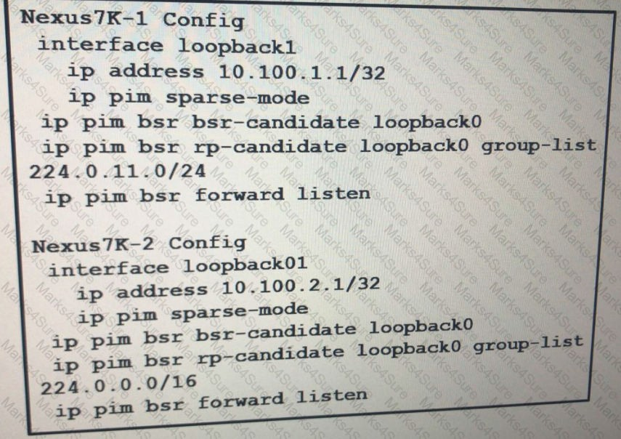

Refer to the exhibit Which description of the result is true?

1. Nexus7K-2 is the RP for all of the multicast addresses specified in the 224.0.11.0/24 group list.
2. Nexus7K-1 is the RP for all of the multicast addresses specified in the 224.0.11.0/24 group list.
3. Nexus7K-2 is the RP for all of the multicast traffic on the network.
4. Nexus7K-1 is the RP for all of the multicast traffic on the network.

## Answer: D

Question #:29

Practice Test

Cisco - 300-180

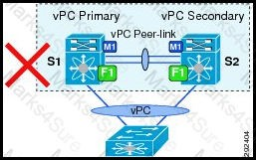

Why do the lists not contain the same switches, after you issue the commands show cfs peers name and show cfs merge status?

1. The merge cannot occur until the VSAN IDs are synched.
2. The Cisco Fabric Services fabric has a physical port fault that should be investigated.
3. The fabric is partitioned into multiple Cisco Fabric Services fabrics.
4. Cisco Fabric Services need to be restarted to see the new switches.
5. A Cisco Fabric Services database lock has prevented the merge.

## Answer: C

Question #:30

Refer to exhibit.

Customer has a pair of Cisco Nexus7010s switches and connected to a single Cisco Nexus5548 switch via vPC. Customer has a combination of M1 and F1 I/O Modules in Cisco Nexus7010s.

Why is the design described not supported?

1. Mixing I/O Modules on the Same Side of a Peer Link is not supported
2. vPC does not support split control plane
3. You can not configure a vPC peer link to configure two devices as vPCs
4. Need to add another Cisco Nexus5548 switch to the topology to make this work.

## Answer: A

Question #:31

Refer to the exhibit.

Practice Test

Cisco - 300-180

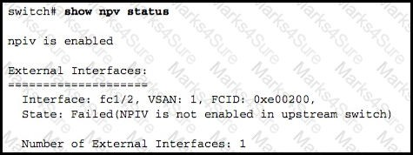

The customer informs you of a problem they are encountering. What is the cause of the problem?

1. The core upstream switch does not have NPIV enabled.
2. The downstream switch does not have NPIV enabled.
3. NPIV has been disabled on all switches.
4. NPIV has been configured but not enabled on the uplink port.

## Answer: A

Question #:32

How can you identify the blade location when tracing server traffic?

1. by performing CDP checks on the Cisco UCS Fabric Interconnects
2. by using a trace utility
3. by collecting traffic that uses a SPAN monitoring port
4. by examining the interface to which the server MAC address is connected

## Answer: A

Question #:33

On a Cisco Nexus 5500 Series Switch, the VFC is stuck in the initializing state. Which QoS statements must be configured for FCoE to operate?

1. system qos

service-policy type qos input fcoe-default-in-policy service-policy type queuing input fcoe-default-in-policy

Practice Test

Cisco - 300-180



service-policy type queuing output fcoe-default-out-policy service-policy type network-qos fcoe-default-nq-policy

1. system qos

service-policy type qos input fcoe-default-in-policy service-policy type queuing input fcoe-default-in-policy service-policy type qos input default-in-policy

service-policy type network-qos default-nq-policy

1. system qos

service-policy type qos input default-in-policy service-policy type queuing input default-in-policy service-policy type queuing output default-out-policy service-policy type network-qos default-nq-policy

1. system qos

service-policy type qos input default-in-policy service-policy type queuing input default-in-policy

service-policy type queuing output fcoe-default-out-policy service-policy type network-qos fcoe-default-nq-policy

## Answer: A

Question #:34

What can prevent you from adding an interface to a pre-existing port-channel on a CISCO Nexus N7K device?

1. The port-channel is In LACP passive mode
2. The interface already assigned to a different port-channel,
3. The interface has been allocated to a different VOC
4. no shutdown was issued on the interface.

## Answer: B

Practice Test

Cisco - 300-180

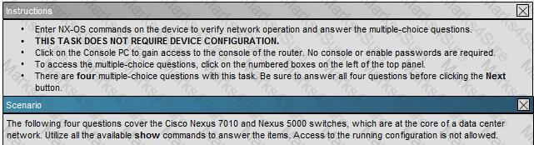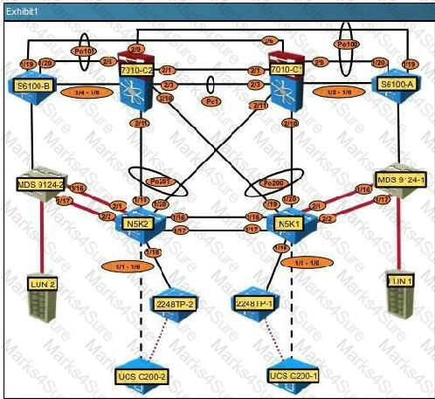

Question #:35

Practice Test

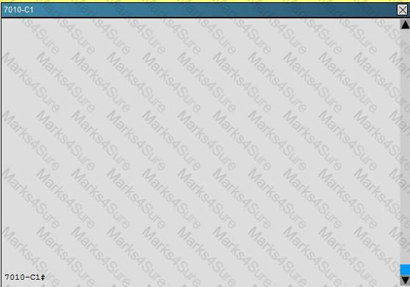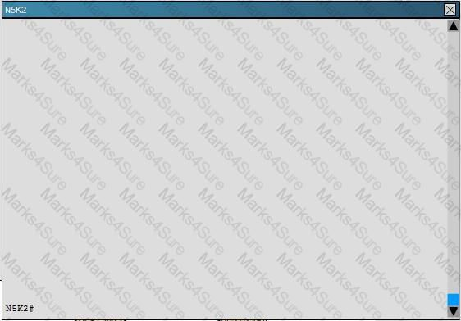

Cisco - 300-180

Practice Test

Cisco - 300-180

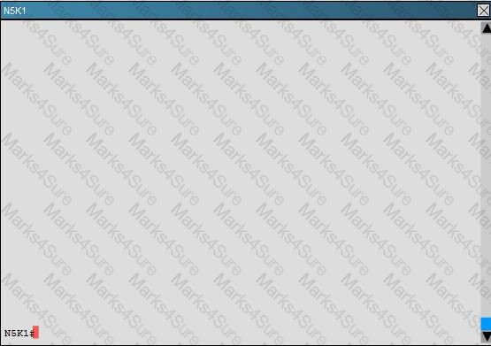

Which statement is true regarding the port channel 100 and 101 configurations between the Nexus 7010 switches?

1. The vPC assignments on N7010-C2 are incorrectly swapped
2. N7010-C1 is not allowing any active VLAN traffic to pass on Po100 and Po101.
3. LACP is not configured to initiate negotiations.
4. The vPC peer-keepalive is down between the two Nexus 7000 switches.

## Answer: A

**Explanation**

The vPC assignments on N7010-C2 are incorrectly swapped.

The “show vpc” command will show you that the keepalives are active, and that there are active VLANs. The “show port-channel summary” command shows that LACP is enabled.

Question #:36

## Which two options are Cisco UCS default user roles? (Choose Two)

1. LAN Administrator
2. FCoE Administrator

Practice Test

Cisco - 300-180

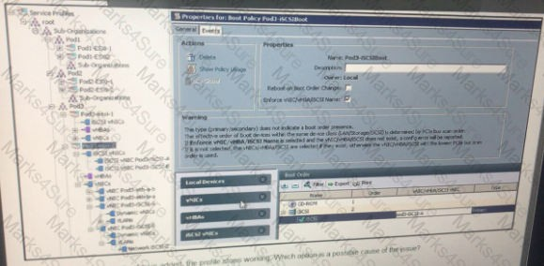

1. Server Equipment Administrator
2. Administrator
3. Server Resource Administrator

## Answer: C D

Question #:37

When a directly connected host pings a switch virtual interface on the Cisco Nexus 7000 Series Switch, there is intermittent ping loss. What is the cause?

1. CoPP is applying microflow policing to all traffic from the host that is destined to the CPU.
2. CoPP is applying microflow policing to all traffic to the host that is leaving the CPU.
3. CoPP is rate-limiting all ICMP traffic that is destined to the CPU.
4. CoPP is rate-limiting all ICMP traffic that is leaving the CPU.

## Answer: C

Question #:38

Refer to the exhibit. After a boot policy is added, the profile stops working, which option is a possible cause of the issue?

1. An iSCSI adapter is being on top of the vNIC

Practice Test

Cisco - 300-180



1. Both of the adapters from the fabric A and fabric B must be specified
2. The name of the adapter is incorrect
3. The boot target does not exist

## Answer: A

Question #:39

Which action do you take to determine why the interface el/10 is not present in the core VDC for configuration?

1. Check the admin VDC to see the port e1/10 is allocated.
2. Check the core VDC to see if the port e1 /10 is allocated.
3. Check to see if the cable is connected to the e1/10 interface,
4. Check to see if vPC is enabled

## Answer: A

Question #:40

Refer to the exhibit.

Practice Test

Cisco - 300-180

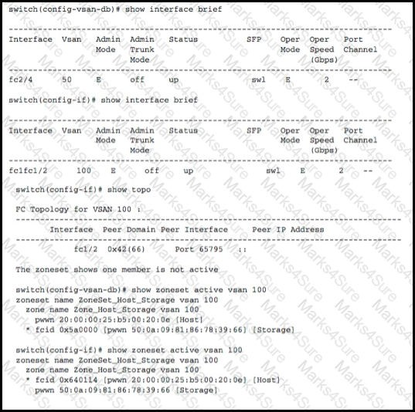

Customer is having problems with a device in VLAN100? What would fix the problem?

1. Move the trunk port into VSAN 100.
2. Change interface fc1fc1/1 into a trunk port and remove VSAN 100.
3. Change interface fc2/4 into a trunk port.
4. Change interface fc2/4 into VSAN 100.
5. Change interface fc1fc1/2 into VSAN 100.

## Answer: D

Question #:41

Which command is critical in order for OTV edge devices to maintain an overlay adjacency with their local peers in a multihomed site via the join interfaces across the Layer 3 network domain?

Practice Test

Cisco - 300-180



1. otv site-identifier
2. otv extend-vlan
3. otv site-vlan
4. otv use-adjacency-server unicast-only

## Answer: A

Question #:42

Which two commands will show all the MAC addresses learned from remote sites in an OTV overlay? (Choose two.)

1. show otv route overlay
2. show otv vlan
3. show ip arp
4. show mac address-table
5. show otv site

## Answer: A D

Question #:43

A Cisco Nexus 7010 Switch that is at the core of a customer network has high CPU utilization. What can the customer do to prevent a network outage and identify why CPU utilization is high?

1. apply a rate limit on the interfaces with high traffic
2. use CoPP
3. use HSRP and vPC for redundancy to handle high CPU utilization
4. use the show process cpu command to see the high CPU utilization

## Answer: B

Question #:44

Which command on a Cisco Nexus 5000 Series Switch will show the interface information for port 10 on the connected FEX 100?

Practice Test

Cisco - 300-180



1. show interface Ethernet 100/10
2. show fex 100 interface Ethernet 1/10
3. show interface Ethernet 100/1/10
4. show interface Ethernet 1/100/10

## Answer: C

Question #:45

Which option is a best practice that should be followed When replacing a CISCO Nexus 5000 Series switch in a vPC topology?

1. Connect a dual-homed Fabric Extender topology fabric port to the replacement switch.
2. Ensure that the vPC role priority of the replacement switch is equal to the existing swtch.
3. Obtain the configuration from the peer switch if the configuration synchronization feature was enabled.
4. Ensure that the vPC role priorty of the replacement switch is better than the existing switch

## Answer: A

Question #:46

What is the default number of dynamic VNICs that is specified by the Cisco UCS Manager when creating a dynamic vNIC connection policy?

A. 256

B. 54 C. 128 D. 257

## Answer: B

Question #:47

**In** an **IP** storage environment, what occurs if you apply a service profile to a server that has an Ethernet-only mezzanine card?

Practice Test

Cisco - 300-180

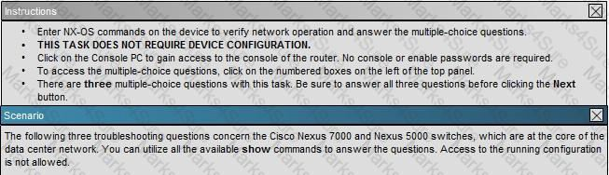

1. The storage adapter is not visible to the OS
2. A blade association occurs,
3. WWPN and WWNN are selected from the default pool
4. The OS fails to boot

## Answer: B

Question #:48

Which statement is true regarding STP?

1. When the spanning-tree topology is calculated based on default parameters, the path between the source and destination end stations in a switched network might not be ideal.
2. The path between the source and the destination end stations is always ideal with the default spanning-tree parameter.
3. The path between the source and the destination end stations is determined by the speed of the link; the slowest link speed will become the root port during the election.
4. The path between the source and the destination end stations is determined by the lowest MAC address; the lowest MAC address will become the root port during the election.

## Answer: A

Question #:49

Practice Test

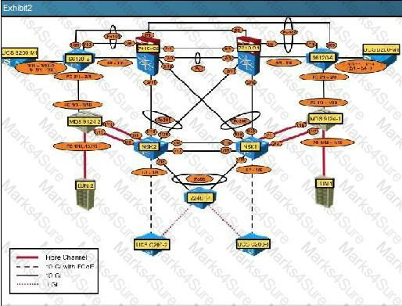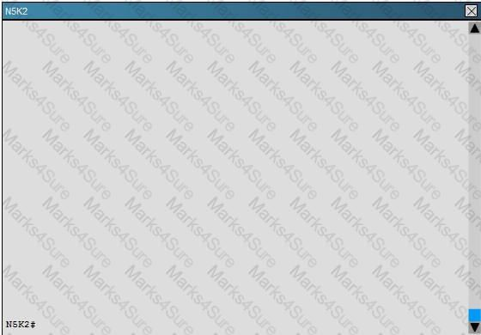

Cisco - 300-180

Practice Test

Cisco - 300-180

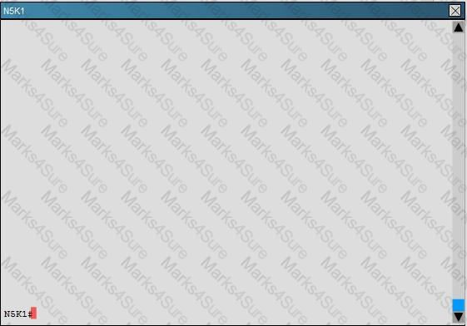

Fibre Channel traffic on VSAN 12 between N5K2 and MDS9124-2 is degraded. Which statement explains the cause of this degradation?

1. Performance is decreased by half due to the incorrect port type being used.
2. The load-balancing scheme for VSAN 12 should be src-id/dst-id.
3. B2B credits on N5K2 should be increased to 128.
4. A VSAN port channel must be configured between N5K2 and MDS9124-2.

## Answer: D

Question #:50

Which command is used to check for potential vPC configuration consistency problems?

1. show vpc brief interface
2. show vpc global config
3. show vpc consistency-parameters global
4. show vpc config

## Answer: C

Practice Test

Cisco - 300-180



Question #:51

At any given time, each server can be associated with how many service profiles?

1. 1
2. 2
3. 5
4. 10
5. unlimited

## Answer: A

Question #:52

When configuring LLDP on Cisco Nexus 5548 Switch, what is the purpose of LLDP hold time global configuration command?

1. LLDP holdtime option is to set the length of time in milliseconds that a device should save LLDP information received before discarding it.
2. LLDP holdtime option is to set the length of time in seconds that a device should save LLDP information received before discarding it.
3. LLDP holdtime option is to set the length of time in milliseconds to wait before performing LLDP initialization on any interface.
4. LLDP holdtime option is to set the length of time in seconds to wait before performing LLDP initialization on any interface.

## Answer: B

Question #:53

Refer to the exhibit.

Practice Test

Cisco - 300-180

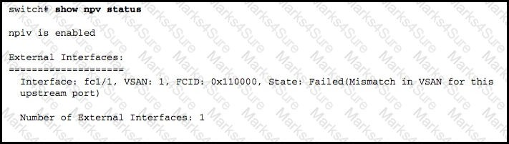

When your customers have NPV problems, which three actions should you take? (Choose three.)

1. Verify that the NPV core switch supports NPIV and that it is enabled.
2. Verify that all ports are properly configured and connected.
3. Ensure that the VLAN values are configured on both sides of the NPV core switch.
4. Verify the status of the servers and external interfaces, using the show npv server status command.
5. Ensure that the VSAN value that is configured on the device links is correct.
6. For all the device links, ensure that the port mode on the NPV device is in Full_port mode.

## Answer: A B E

Question #:54

Which two conditions can prevent vFC from coming up? (Choose two.)

1. PFC is enabled.
2. DCBX is disabled.
3. LDP is disabled.
4. vPC is enabled.
5. VSAN trunking is enabled

## Answer: B C

Question #:55

Which command would you use to check the status of your configuration synchronization peer?

Practice Test

Cisco - 300-180

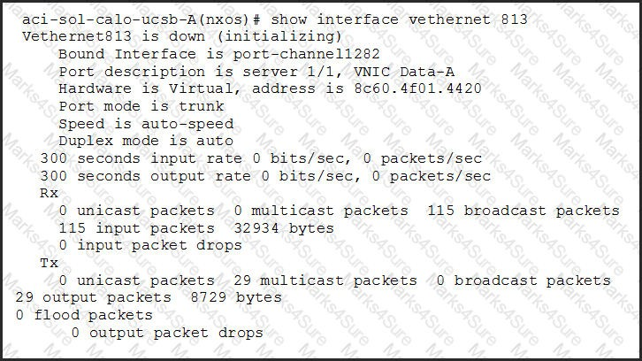

1. N5K2# show switch-profile peer
2. N5K2# show config-sync peer
3. N5K2# show synch peer
4. N5K2# show peer status
5. N5K2# show switch peer

## Answer: A

Question #:56

Refer to exhibit.

A Cisco UCS admin is troubleshooting an issue with a vNIC not coming up on a blade. When looking at the CLI of the "Fabric Interconnect",the admin runs this command to view the status of the interface. Which option describes a possible reason why the interface is stuck in an "initializing" state?

1. The service profile is not applied to a blade.
2. The VLANs defined on the vNIC are not defined on a matching uplink port.
3. The uplink port is down.

Practice Test

Cisco - 300-180



1. The QoS policy on the vNIC is invalid.
2. The MTU on the vNIC is higher than the MTU configured in the QoS system class.

## Answer: C

Question #:57

Which two commands will show all the OTV edge devices and their MAC addresses in the local site? (Choose two.)

1. show otv overlay
2. show otv site
3. show otv vlan
4. show otv adjacency
5. show mac address-table

## Answer: B D

Question #:58

Which statement is true regarding FHRP considerations for an OTV network?

1. VRRP is recommended over HSRP or GLBP.
2. Using an AED eliminates the need for FHRP.
3. FHRP should be limited to only the internal OTV interfaces.
4. Filtering FHRP across the OTV network is recommended to avoid a suboptimal path due to the election of a single default gateway.

## Answer: D

Question #:59

Which method does Cisco recommend for recovering a fabric interconnect when you have no working images on the bootflash?

1. reboot the primary fabric interconnect.

Practice Test

Cisco - 300-180

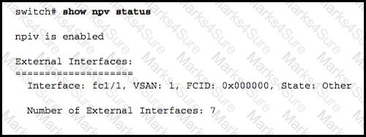

1. Receive the kickstart image by using TFTP.
2. Download the system image.
3. Initiate auto-install.

## Answer: B

Question #:60

You have three VDCs named VDCI, VDC2 and VDC3 connected to the same environment, Due to a network device malfunction, there is an ARP storm in VDC1 Users in VDC2 discover that

ARP is not resolving in VDC1. What is causing the issue?

1. The committed information rate is exceeded.
2. VDC1 is responsible for processing ARP for all of the VDCs,
3. The CoPP settings for VDC1 are Incorrect.
4. The CoPP settings for VDC2 are incorrect,

## Answer: A

Question #:61

Refer to the exhibit.

A customer is having a problem getting NPV to work. What is causing the problem?

1. The core NPV switch port is not an F port.
2. The core NPV switch port is in a shutdown state.

Practice Test

Cisco - 300-180

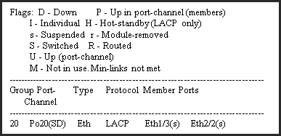

1. The core NPV switch port is not configured on both ends.
2. The core NPV switch port is not configured on the other end.
3. The core NPV switch ports are in the wrong domain.

## Answer: A

Question #:62

Refer to the exhibit.

An administrator is trying to configure a port channel on a Cisco Nexus 7000 Series Switch, which is connected to a Cisco Nexus 5500 Series Switch. The port channel will not come up, so the administrator executes the **show port-channel summary** command on the Cisco Nexus 7000 Series Switch and displays the output.

What are two causes of the error? (Choose two.)

1. The Cisco Nexus 7000 Series Switch needs to be configured with no lacp suspend-individual.
2. The Cisco Nexus 5500 Series Switch is configured with channel-group mode on.
3. The LACP feature has not been enabled on the Cisco Nexus 7000 Series Switch.
4. The ports are cabled to the wrong switch.
5. The port channel load-balancing algorithm does not match.

## Answer: B D

Question #:63

You use external storage to boot Cisco UCS B-series servers, The servers also have internal disks, You discover that one of the servers fails to boot from the SAN Other servers successfully boot from the SAN,

Practice Test

Cisco - 300-180

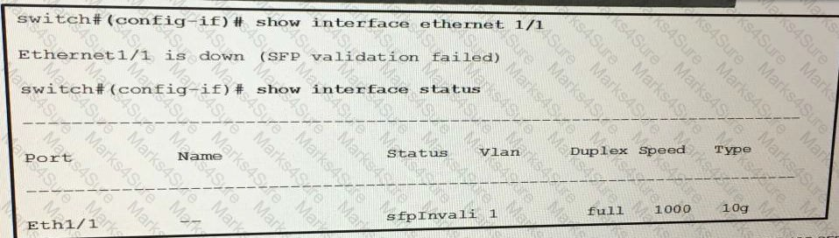

What are too possible causes of the Issue? (Choose too)

1. cabling
2. the QOS settings on the Fabric Interconnect
3. the power consumption of the blade
4. zoning
5. LUN masking on the storage array

## Answer: D E

Question #:64

**Refer to the exhibit.**

**You connect Cisco Nexus 5600 Series switches to Cisco Nexus 2200 Series Fabric Extenders by using FET-10G SFPs. Which command resolves the error that is shown in the exhibit?**

1. switch#(config-if)# switchport mode dotlq tunnel trunk
2. switch#(config-if)# switchport mode fex-fabric
3. switch#(config-if)# switchport mode dynamic desirable
4. switch#(config-if)# switchport mode fabricpath

## Answer: B

Question #:65

Practice Test

Cisco - 300-180

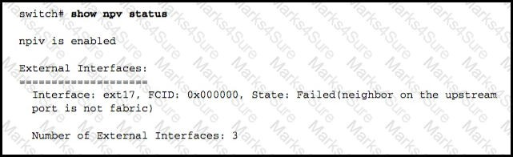

Refer to the exhibit.

A customer is having difficulty getting NPV working. What is the cause of the problem?

1. The core NPV device is not enabled.
2. The core NPV device is not a switch.
3. The core NPV device is not configured on both ends.
4. The core NPV device is not configured on the upstream port.

## Answer: B

Question #:66

Which two conditions can prevent FCoE from functioning properly across a link? (Choose two.)

1. LLDP is disabled.
2. PFC was negotiated across the link.
3. DCBX is enabled on the device.
4. The VFC interface is down.
5. The VSAN trunking protocol was enabled.

## Answer: A D

Question #:67

**A leaf is programmed with the correct VLANs and Interfaces, but the servers in web EPG are unreachable from the** outside Layer 2 **network. You use a unique** external L2out EPG as a Layer 2 extension Inside the Cisco ACI fabric. Which **action do you take to** resolve the communication issue?

Practice Test

Cisco - 300-180



1. Configure an MTU of 9000 bytes on the devices in the L2out EPG
2. Configure contracts between the web EPG and the L2out EPG
3. Bind the web **EPG** to a port/leaf.
4. **Enable** a spanning tree on the VLANs on the leaf.

## Answer: C

Question #:68

A customer has two data centers, containing two Cisco Nexus 7000 switches. For redundancy, HSRP and vPC have been implemented. The customer implemented OTV to extend VLAN 325 between data centers and there is one default gateway over the four Cisco Nexus 7000 switches.

A. 001e.0C9F.F145 B. 0000.0C9f.F145 C. 001e.0C07.A145 D. 0000.0C07.A145

## Answer: D

Question #:69

Which command output shows the interface assigned as the designated receiver of each VLAN?

1. show system vlan reserved
2. show vlan internal bd-info bd-to-vlan all-bd
3. show port internal info all
4. show platform software enm internal info vlandb all

## Answer: D

Question #:70

Refer to the exhibit.

Practice Test

Cisco - 300-180

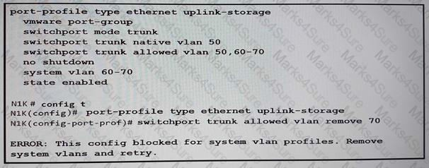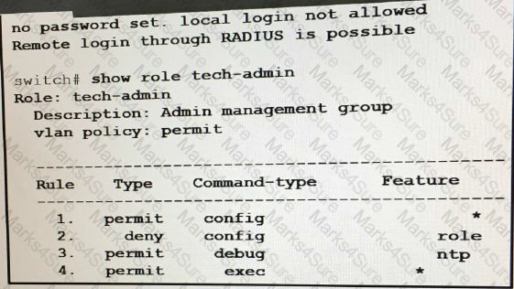

Which action removes the system designation from VLAN 70?

1. Create another port profile that excludes VLAN 70
2. Shut down the port profile first
3. Delete the uplink-storage port profile, and then receive it
4. Remove VLAN 70 from the trunk first

## Answer: A

Question #:71

Refer to the exhibit.

Practice Test

Cisco - 300-180



A user named user1 is unable to create roles. What must you do to resolve the issue?

1. Assign user1 to the network-admin role.
2. Assign user1 to the tech-admin role only.
3. Set the user password for user1
4. Allow user1 to log in locally

## Answer: A

Question #:72

The installation of a new OTV network connecting two data centers via a service provider LAN has failed verification steps. Which statement explains why certain types of data are not being successfully transferred across the OTV network?

1. The number of extended VLANs across all configured overlays may be greater than 256.
2. The number of MAC addresses on either edge device may exceed 4000.
3. The additional 42-byte OTV overhead, along with the DF bit being set, may cause the service provider to drop packets based on their 1500 MTU settings.
4. Having more than two edge devices per site is not supported.

## Answer: C

Question #:73

Which two statements are true regarding vPC configuration? (Choose two.)

1. With vPC, there are no blocked ports.
2. vPC uses hash-based EtherChannel load balancing.
3. There are STP-blocked redundant links.
4. There is VLAN-based load balancing.
5. There is higher oversubscription.

## Answer: A B

Question #:74

Practice Test

Cisco - 300-180

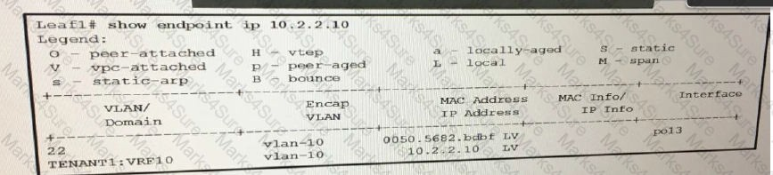

Refer to the exhibit.

Which statement accurately described the output?

1. There are two EPGs associated to the 10.2.2.10 IP address
2. The displayed endpoint is attached via a vPC.
3. The displayed endpoint is a local VTEP
4. There are two endpoints associated to the 10.2.2.10 IP address

## Answer: D

Question #:75

A customer is troubleshooting FCoE in its network. They have discovered that vFC is currently down and there is no active STP port state on the bound Ethernet interface. What should the STP port state be to correct this issue?

1. The bound interface should be in an STP forwarding state for the native VLAN only.
2. The bound interface should be in an STP learning state for both the native VLAN and the member FCoE VLAN that is mapped to the active VSAN.
3. The bound interface should be in an STP forwarding state for both the native VLAN and the member FCoE VLAN that is mapped to the active VSAN.
4. The bound interface should be in an STP blocking state for both the native VLAN and the member FCoE VLAN that is mapped to the active VSAN.

## Answer: C

Question #:76

Practice Test

Cisco - 300-180

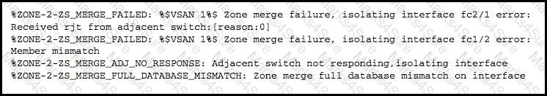

After a data center is upgraded with new Cisco Nexus switches, some of the links **using** multimode fiber no longer work, which type Of **multimode** cables are valid?

1. OM4 cable for 700 mat 10 Gb
2. OM3 cable for50 m at 40 Gb with QSFP BiDi
3. OM4 cable for 150 m at 40 Gb QSFP BiDi
4. OM2 cable for 550 mat 10 Gb

## Answer: B

Question #:77

Refer to the exhibit.

In the initial SAN deployment or after topology changes in the SAN, some hosts cannot communicate with storage. What are three possible causes of the problem? (Choose three.)

1. misconfigured fabric timers
2. misconfigured port parameters
3. VSAN pruning
4. VSAN trunking issues
5. VLAN problems
6. mismatched zoning

## Answer: A B F

Question #:78

A customer calls you to report that it receives an error when entering the pinning max-links 4 command in FEX configuration mode on its Cisco Nexus 5596T Switch. Which of these is a likely cause for this condition?

Practice Test

Cisco - 300-180



1. The FEX fabric interface is down.
2. The transceiver is incorrect.
3. A fabric interface is in a port channel.
4. The fabric interface switchport mode is set to Access.
5. Only two fabric interfaces are connected.

## Answer: C

Question #:79

One of your Cisco Nexus Series interfaces has become errdisabled with the error message "DCX-No ACK in 100 PDUs". How often are these acknowledgements exchanged?

1. 15 seconds
2. 30 seconds
3. 45 seconds
4. 60 seconds

## Answer: B

Question #:80

You are troubleshooting a Cisco Nexus 1000V Series Switch. Which command can you use to re-establish communication between VSM and VMware vCenter?

1. reset
2. connect
3. setup
4. reload

## Answer: A

Question #:81

Practice Test

Cisco - 300-180

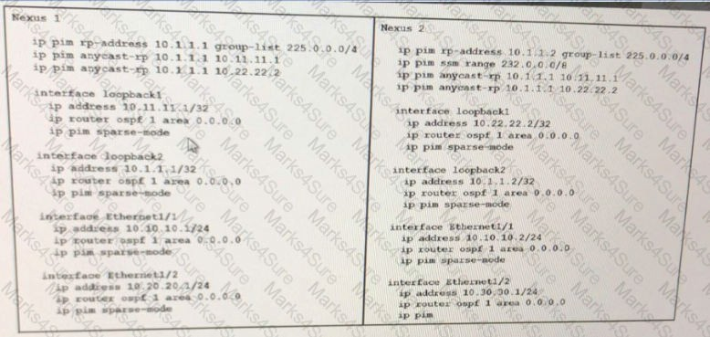

Refer to the exhibit. Anycast RP fails. Which two actions do you perform to resolve the issue? (Choose two.)

1. Configure the IP address of Anycast RP to use the multicast range.
2. Change the loopback2 interface on Nexus 2 to 10.1.1.1/32.
3. Change the pim rp-address on Nexus 2 to 10.1.1.1.
4. Add the pim ssm range to Nexus 1.
5. Set the pim ssm range on Nexus 2 to 225.0.0.0/24

## Answer: B E

Question #:82

You discover that OSPF neighbors are stuck in Exstart and Exchange states.

What prevents the external routes from being propagated to the leaf switches to which endpoints **are** attached for a given tenant?

1. The outside router is configured with an incorrect OSPF area ID.
2. there is an MTU mismatch between the OSPF neighbors.
3. The outside router is configured with an incorrect OSPF area type.

Practice Test

Cisco - 300-180



1. The outside router is configured for MTU 9000.

## Answer: B

Question #:83

What happens to Copp after you perform an ISSU?

1. The default Copp policy is applied.
2. packets that need special handling by the supervisor module cannot be matched.
3. The statistical counters are reset.
4. **All** traffic is put into the default class of the Copp policy

## Answer: C

Question #:84

After disassociating a service profile from a server, you attempt to associate the service profile to a different server. Which policy in the service profile can prevent it from being associated to a different server?

1. SAN connectivity
2. maintenance
3. LAN connectivity
4. power management

## Answer: D

Question #:85

After moving Cisco UCS to a new data center that has a different management IP network, you discover that the KVM Stops working. What is a possible cause of the issue?

1. The management IP block uses the same subnet as the management port ot the UCSM.
2. The management IP block uses a different subnet than the management port of the UCSM.
3. The management IP block is not cleared,
4. The management IP block is not defined.

## Answer: B

Practice Test

Cisco - 300-180



Question #:86

A customer is trying to boot an operating system that is installed on the eUSB on a Cisco UCS B-Series blade server; however, the boot fails. What is the cause of this failure?

1. The local disk must be the first device in the boot order.
2. eUSB is not a supported boot device.
3. eUSB support is available only on the Cisco UCS C-Series rack server.
4. eUSB is not the first device in the boot order for the server.

## Answer: D

Question #:87

Which two features are required to configure a blade to boot successfully from Fibre Channel? (Choose two.)

1. LUN masking
2. WWPN device alias
3. boot from SAN policy
4. SAN connectivity policy
5. port assignment

## Answer: B C

Question #:88

You install a new DIMM in a Cisco UCS C-Series standalone rack server and that DIMM is not recognized by the server. What actions do you take to troubleshoot the problem? (Choose two)

1. Remove an old DIMM from the blue memory slot and install the new DIMM there.
2. Verify that the DIMM has been qualified to work on Cisco UCS servers.
3. Return the DIMM for a new replacement.
4. Remove and dispose of the bad DIMM.
5. Verify that the DIMM is in a slot that supports an active CPU.

## Answer: B D

Practice Test

Cisco - 300-180

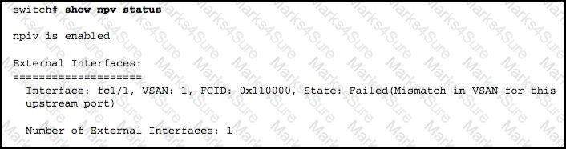

Question #:89

Which CLI command can tell which switch is on the other side of port channel 2 that is trunking VSAN 5?

1. show topology vsan 5
2. show interface port-channel 2 trunk vsan 5
3. show interface port-channel 2 vsan 5 peer-info
4. show fcs vsan 5
5. show fspf database vsan 5 interface port-channel 2

## Answer: A

Question #:90

Refer to the exhibit.

A customer is having problems with NPV. Which of these is the cause of the problem?

1. No server was requested or received by the FLOGI database.
2. One external link must be up for server interface to be up.
3. Internal links are down and must be up for the server interface to be up.
4. VSANs are misconfigured on the upstream ports.
5. VLANs are misconfigured on the upstream ports.

## Answer: D

Practice Test

Cisco - 300-180

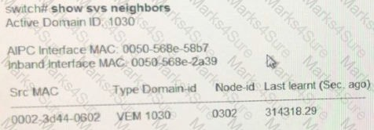

Question #:91

An engineer enters the show svs neighbors command as shown below. Which statement describes the output of the command?

1. The VSM cannot connect to the VEM.
2. The vCenter server cannot connect to the VSM.
3. The VSM is connected to the VEM by using an Layer 2 network.
4. The VSM is connected to the VEM by using an Layer 3 network.

## Answer: B

Question #:92

From Cisco UCS Central, you plan to add two Cisco UCS domains that use the same name for the WWPN pool. What must you do to ensure a successful Integration?

1. Rename the pools to have the same name.
2. Assign WWPN pools to Different users.
3. Move the WWPN pools to different organizations.
4. Remove duplicate WWPN pools.

## Answer: B

Question #:93

Practice Test

Cisco - 300-180

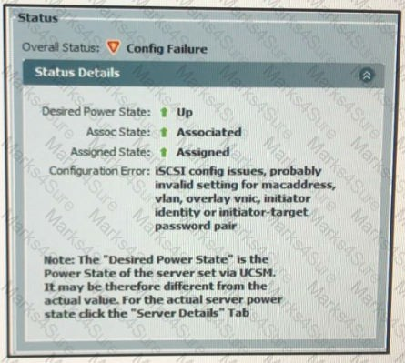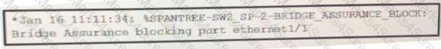

Refer to the exhibit. You fail to configure a boot from iSCSI service profile. Which action do you take to troubleshoot the issue?

1. Attempt to ping the IP address of the iSCSI target.
2. Check the LUN masking configuration.
3. In the CLI of Cisco UCS Manager, verify that the blade is attached to the LUN.
4. Check the native VLAN configuration on the overlay vNIC.

## Answer: D

Question #:94

Refer to the exhibit. You discover that eth1/1 stopped forwarding data. Which option describes how to resolve the issue?

1. Reboot the switch.
2. On the adjacent switch, run the spanning-tree port type network command.

Practice Test

Cisco - 300-180



1. On the switch, change the STP type.
2. On the adjacent switch, disable bridge assurance.

## Answer: C

Question #:95

A customer reports that a 10-Gb interface between a Cisco Nexus 7009 Switch and a Cisco Nexus 5548UP Switch is not passing traffic. The Nexus 7009 interface indicates up/up. The Nexus 5548UP interface indicates up/down. Which feature should you enable to help isolate the root cause?

1. CDP
2. GOLD
3. UDLD
4. DAI
5. LACP

## Answer: C

Question #:96

Refer to the exhibit.

Practice Test

Cisco - 300-180

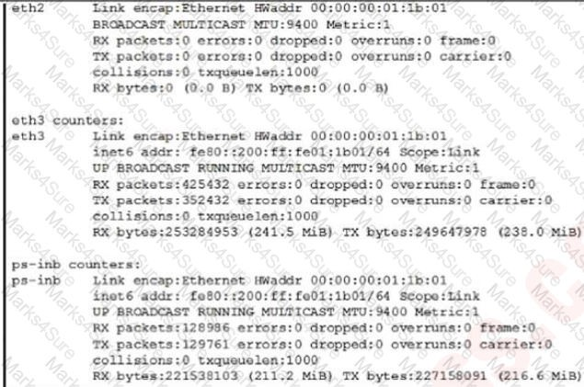

Which command was used to produce the output for the inband packet statistics?

1. show hardware internal cpu-mac inband counters
2. show system internal interface counters module
3. show interface counters all

## Answer: A

Question #:97

Which statement is true regarding the admin VDC?

1. All licensed features and feature sets must be enabled from the admin VDC.
2. Fabric extenders connected to the admin VDC must be statically pinned.
3. Only the mgmt 0 interface is allocated to the admin VDC.
4. All interfaces other than mgmt 0 are allocated to the default VDC.
5. The admin context can only be created on Supervisor 2/2E.

Practice Test

Cisco - 300-180



1. The admin VDC is a new feature in Cisco NX-OS version 6.0.

## Answer: C

Question #:98

Within Cisco UCS Manager, which two types of objects can be restricted by using RBAC? (Choose two.)

1. service profiles
2. roles
3. users
4. locales
5. RADIUS

## Answer: B D

Question #:99

Which statement is true regarding how OTV edge devices will react based on the configuration of the VLANs being extended across the overlay network?

1. Any VLANs not extended will not be populated in the local OTV route table.
2. Only the same-site edge AED device controls which VLANs are to be extended.
3. Any extended VLANs will not be populated in the remote OTV route table.
4. By default, all VLANs on an edge device will be extended.

## Answer: A

Question #:100

Refer to the exhibit.

Practice Test

Cisco - 300-180

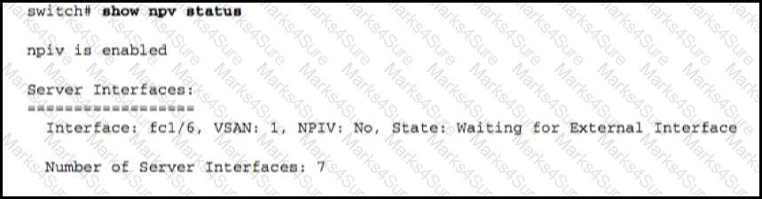

A customer is having a problem with NPV. Which of these is the cause of the problem?

1. No server was requested or received by the FLOGI database.
2. One external link must be up for server interface to be up.
3. Multiple external links must be up for the server to come up.
4. Internal links are down and must be up for the server interface to be up.

## Answer: B

Question #:101

You upgrade Cisco UCS Director. When you power on the Cisco UCS director VM, the websock service fails to start. Which action do you take to resolve the issue?

1. Resynchronize the NTP time and time zone information on each node.
2. Import the correct SSL certificates
3. After you power on the VM, press Alt-F 1 to refresh the VMware console.
4. Ensure that the websock service starts automatically after an upgrade.

## Answer: B

Question #:102

Refer to the exhibit.

Practice Test

Cisco - 300-180

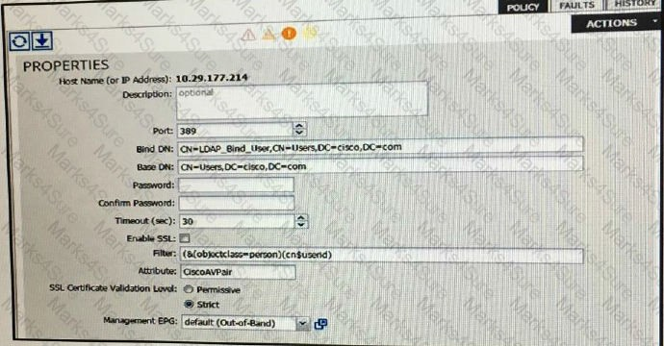

You are configuring a Cisco APIC for access. Which task is being performed in the exhibit?

1. configuring APIC management EpG
2. creating the LDAP logjn domain
3. creating the LDAP provider
4. creating the LDAP provider group

## Answer: C

Question #:103

Which two ports must be open on a VMware vCenter server to allow communications to a Cisco Nexus 1000V Series Switch? (Choose two)

A. 80 B. 443

C. 21 D. 2010

E. 20

## Answer: A B

Practice Test

Cisco - 300-180



Question #:104

A customer reports that they are missing vPC peer link redundancy between two Cisco Nexus 5548UP switches The interfaces on both switches are

configured and cabled correctly. The interface status is up/down on switch 1 and up/up on switch 2, Which two steps should be taken to isolate the root

cause? (Choose two.)

1. Swap the ends of the fiber-optic cable
2. ask the customer if the link was ever functional
3. determine whether the fiber-optic cable manufacturer is valid under the interoperability matrix
4. swap the transceivers between the two interfaces
5. determine Whether the fiber-optic cable type (single mode or multimode) matches the X2 modules

## Answer: A D

Question #:105

Refer to Exhibit.

Practice Test

Cisco - 300-180

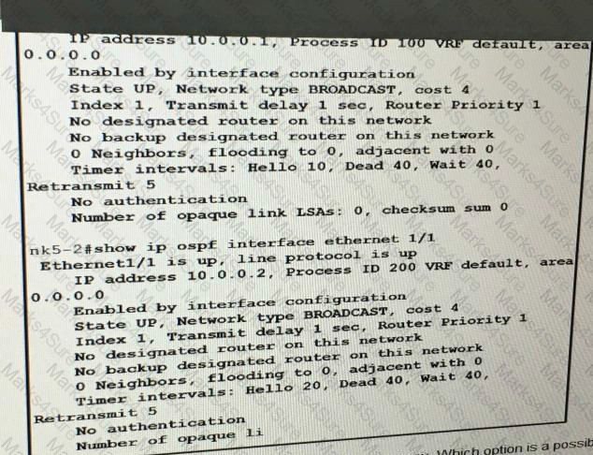

The Cisco Nexus 5000 Series Switches fail to form an OSPF adjacency. Which option is a possible cause of the issue?

1. The interfaces are disabled.
2. The network type is set to broadcast
3. There is mismatched process ID
4. The OSPF hello timer values are mismatched.

## Answer: C

Question #:106

Which three of these would cause two switch fabrics not to merge? (Choose three.)

1. Two or more switches do not have at least one assigned domain ID in common.
2. Two switches have different assigned VSANs on the connecting ports.
3. Two switches have different assigned VLANs on the connecting ports.

Practice Test

Cisco - 300-180



1. The static domain ID does not override the dynamic ID.
2. The election of the static domain is only determined by the WWNs of the two switches.
3. The physical connectivity between the two switches is not active.

## Answer: A B F

Question #:107

Which statement is true about the show cfs merge status name command?

1. In a successful merge, all switches in the fabric are shown separately.
2. The command shows the complete Cisco Fabric Services region database.
3. The merge master is selected based on the highest sWWN in the fabric.
4. In a successful merge, all switches are shown in a local fabric.

## Answer: D

Question #:108

Which CLI command identifies the service profile that is associated with a particular compute blade, VIF, vNIC type, link state, and pinned interface?

1. show service-profile path server 1/2
2. show service-profile circuit server 1/2
3. show server-blade circuit server 1/2
4. show server-blade path server 1/2

## Answer: B

Question #:109

Which command displays the traffic statistics for a port channel interface?

1. show interface port-channel channel-number
2. show port-channel traffic

Practice Test

Cisco - 300-180



1. show port-channel usage
2. show port-channel compatibility-parameters

## Answer: B

Question #:110

Which command would you use to find the AED of an extended VLAN in a dual-homed site of an OTV network?

1. show otv aed on the AED
2. show otv site on any edge devices in the site
3. show otv vlan on the AED
4. show otv aed on any edge devices in the site
5. show otv vlan on any edge devices in the site

## Answer: C

Question #:111

Refer to the exhibit.

Practice Test

Cisco - 300-180

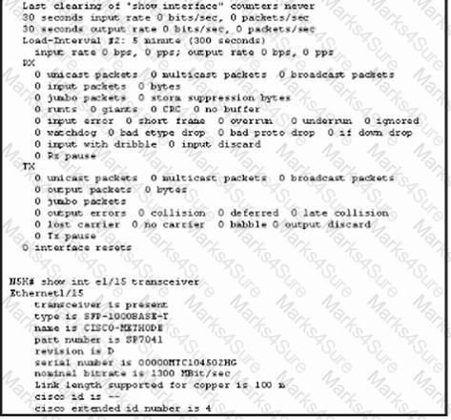

The output displays a failed SFP **validation.** What is the cause of the failure?

1. The fiber is not connected to the SFP
2. The SFP is not a valid Cisco SFP
3. The speed needs to be changed to 10000,
4. The speed needs to be changed to 1000

## Answer: A

Question #:112

What the default MTU size of a VMware host?

|  |  |
| --- | --- |
| A. | 1000 |
| B. | 1500 |
| C. | 1550 |
| D. | 9000 |

Practice Test

Cisco - 300-180

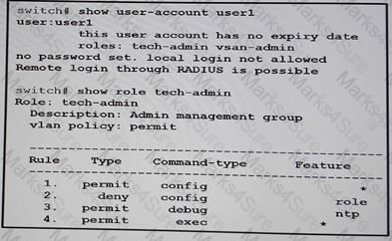

## Answer: B

Question #:113

Which two commands will help an administrator identify any issues with an In-Service Software Upgrade? (Choose two.)

1. show cts interface
2. show incompatibility system
3. show license file
4. show install impact all
5. show install issu-failure

## Answer: B D

Question #:114

Refer to the exhibit.

A user named user 1 cannot create roles. Which action do you take to resolve the issue?

1. Allow user 1 to log in locally.
2. Assign user1 to the network-admin role.
3. Assign user1 to the tech-admin role only.
4. Set the user password for user1.

Practice Test

Cisco - 300-180

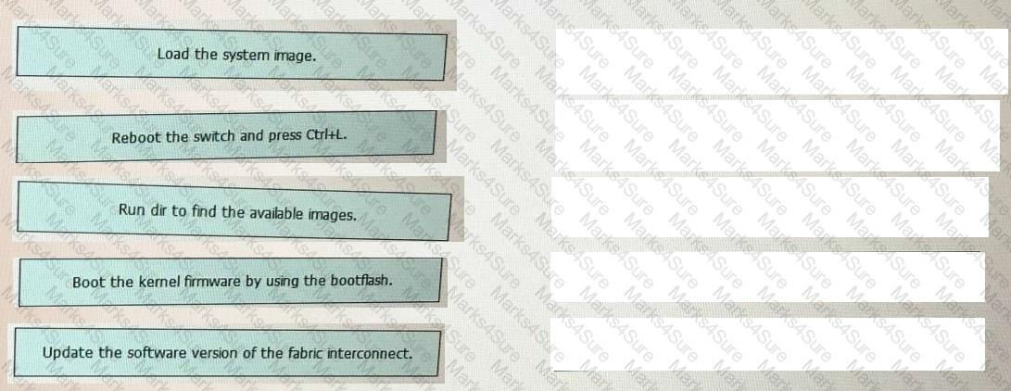

## Answer: D

Question #:115

Two fabric interconnects fail during a Cisco UCS firmware upgrade. Drag and drop the recovery steps from the left into the correct order on the right.

## Answer:

Practice Test

Cisco - 300-180

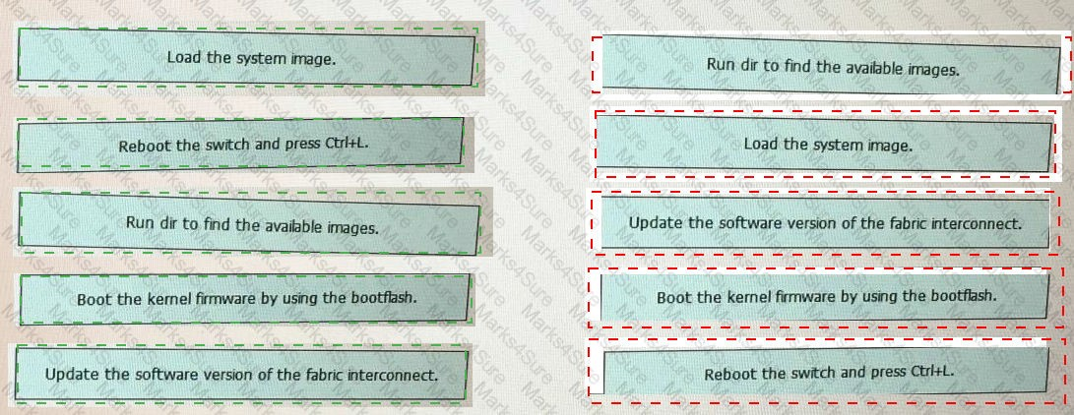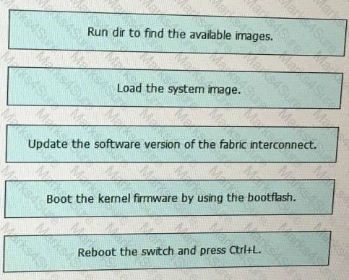

Question #:116

Within Cisco UCS Manager you create a user named ccnpdc and an organization named ccnpdc. The administrator to whom the ccnpdc credentials are assigned fails to access the ccnpdc organization. What must

Practice Test

Cisco - 300-180



you do to provide the ccnpdc user access to the ccnpdc organization?

1. assign a locale
2. assign a role
3. set the password expire time
4. enable the user account

## Answer: A

Question #:117

Your customer is an ISP providing service to thousands of end customers. Its main concerns are focused on using up the total number of 4096 VLANs per VDC, wasting an unused block of IP addresses, and IP address management. Which technique will address these concerns?

1. create a separate VDC to scale VLAN limitation and upgrade to Cisco Nexus 7018 Switch
2. segment VLANs using secondary IP addresses, which will reduce the management domain
3. create mapping between the VLAN and VSAN to run FCoE to consolidate VLAN and IP addresses
4. use PVLANs, which will solve the scalability problem and provide IP address management

## Answer: D

Question #:118

There is an ARP storm in VDC 1. Some users on VDC 2 notice that ARP is not resolving for their gateway on the Cisco Nexus core. What is the cause?

1. The ARP CoPP class committed information rate is exceeded, resulting in ARP loss in all VDCs.
2. The administrator has not correctly configured the ARP CoPP class in VDC 2.
3. The ARP traffic in VDC 1 is copied to the host ports in VDC 2, causing overutilization and output discards.
4. Because the ARP process in the default VDC (VDC 1) is responsible for processing ARP traffic for all VDCs, VDC 2 will be affected.

## Answer: A

Question #:119

Practice Test

Cisco - 300-180



When using a Cisco Nexus 5500 and Cisco Nexus 7000 Series Switch, how can a port channel interface be configured?

1. Layer 3 interface
2. Layer 3 interface in non-admin VDC only
3. Layer 3 interface in admin VDC only
4. Layer 3 interface in VDC 1 only

## Answer: A

Question #:120

You plan to use OSPFv2 on several Cisco Nexus 9000 Series Switches. Which setting must match on the neighboring switches to establish adjacency?

1. the LSA arrival time
2. the dead interval
3. the last flood scan time
4. the retransmit interval

## Answer: A

Question #:121

Which statement about the Nexus atomic rollback feature is true?

1. it restores the default manufacturing configuration.
2. Each error must be acknowledged prior to implementation.
3. it is implemented only if error occur.
4. it is implemented and any errors are skipped.

## Answer: C

Question #:122

Practice Test

Cisco - 300-180

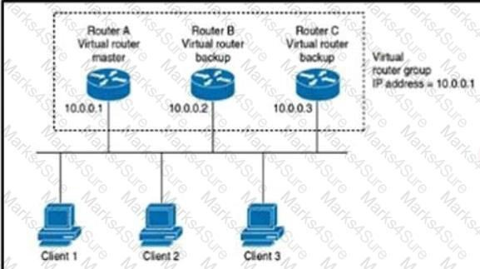

Refer to the exhibit.

Which statement **about** the topology is true?

1. Traffic to and from LAN clients is sent through the master router only.
2. Clients 1, Client 2, and Client 3 are configured to have the default gateway IP address of 10.0.0.1.
3. If Router A fails, the highest interface IP address backup router becomes the master.
4. Multiple VRRP groups are configured on each router.

## Answer: A

Question #:123

What is the default number of dynamic vNICs that is specified by the Cisco UCS Manager when creating a dynamic vNIC connection policy?

A. 54 B. 128 C. 256 D. 257

## Answer: A

Question #:124

Practice Test

Cisco - 300-180



Refer to the exhibit.

When your customers have NPV problems, which two actions should you take? (Choose two.)

1. Verify that the NPV core switch supports NPIV and that it is enabled.
2. Ensure that the VLAN values are configured on both sides of the NPV core switch.
3. Verify the status of the servers and external interfaces, using the show npv server status command.
4. Ensure that the VSAN value that is configured on the device links is correct.
5. For all the device links, ensure that the port mode on the NPV device is in Full_port mode.

## Answer: A B

Question #:125

If no traffic was ever sent across the overlay, what will the show mac address-table command on the OTV VDC indicate?

1. invalid command
2. the MAC address of the local OTV join interface
3. the system IDs of all the local OTV edge devices
4. the system IDs of all the local and remote edge devices in the overlay
5. all the MAC addresses learned on the extended VLAN

## Answer: B

Question #:126

Practice Test

Cisco - 300-180



Which two of these would cause two switch fabrics not to merge? (Choose three.)

1. The switches do not have at least one assigned domain ID in common.
2. Two switches have different assigned VSANs on the connecting ports.
3. The switches have different assigned VLANs on the connecting ports.
4. The static domain ID does not override the dynamic ID.
5. The election of the static domain is only determined by the WWNs of the two switches.

## Answer: B C

Question #:127

Which two statements are true regarding vPC?

1. There is higher oversubscription
2. STP is disabled.
3. With vPC, there are no blocked ports
4. There is VLAN-based load balancing.
5. A peer link is required.

## Answer: B C

Question #:128

Which statement is true regarding LACP configuration?

1. With LACP, you can bundle up to 16 interfaces in a channel group.
2. LACP configuration is global and can be only configured by admin.
3. After removing LACP configuration, you need to reboot the device.
4. You can disable LACP while any LACP configurations are present.

## Answer: A

Question #:129

Practice Test

Cisco - 300-180



Which two options would cause switch fabrics not to merge? (Choose two.)

1. The switches have different assigned VSANs on the connecting pons.
2. The switches do not have at least one assigned domain ID in common.
3. The election of the static domain is only determined by the WWNs of the two switches,
4. The switches have different assigned VLANs on the connecting ports.
5. The static domain ID does not override the dynamic **ID**

## Answer: A B

Question #:130

Practice Test



Cisco - 300-180

Practice Test

Cisco - 300-180



It has been determined that unknown unicast, multicast, and broadcast traffic is not correctly being switched through either Nexus 7010 switch. Which statement best describes the cause of this issue?

1. No VLANs are allowed across the vPC peer link.

Practice Test

Cisco - 300-180

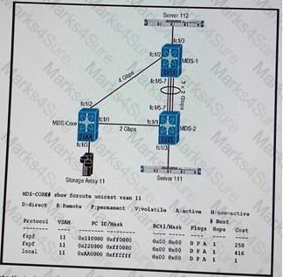

1. The MST STP is not enabled on either switch.
2. The default VLAN is inactive.
3. VTP is not configured to handle this type of traffic.

## Answer: B

**Explanation**

The MST STP is not enabled on either switch

From both switches the “show spanning-tree mst” command shows that the switch is not in MST mode.

Question #:131

Refer to the exhibit.

Your customer reports that all storage traffic from storage array 11 to server 111 is taking the longest path, traveling from MDS-1 to MDS-2. You start troubleshooting the issue buy checking the Fibre Channel routing table. Which configuration set fixes the customer issues without affecting the storage array route of server 112?

1. MDS-Core(config)# interface fc1/1

MDS-Core(config-if)# fspf cost 90 vsan 11

1. MDS-Core(config)# interface fc1/1 MDS-Core(Config-if)# cost 80 vsan 11

Practice Test

Cisco - 300-180



1. MDS-Core(config)# interface fc 1/1

MDS-Coe(config-if)# fspf cost 60 vsan 11

1. MDS-Core(config)# interface fc1/1

MDS-Core(config-if)# fspf cost 70 vsan 11

## Answer: C

Question #:132

Which two statements are true regarding vPC? (Choose two,)

1. A peer link is required,
2. STP is disabled.
3. There is VLLN-based load balancing
4. with vPC, there are no blocked ports

## Answer: A D

Question #:133

Practice Test



Cisco - 300-180

Practice Test

Cisco - 300-180



While the Nexus 7010 switches are configured with vPC, the Nexus 5000 switch connections to each Nexus 7010 are configured as regular port-channels. Which statement best describes the problem affecting the port channel on N5K1?

1. LACP is not configured to initiate negotiations.

Practice Test

Cisco - 300-180



1. N5K1 must also be configured with vPC.
2. load-balancing is not configured correctly on N5K1.
3. The remote ends of the port-channel on N5K1 cannot use the same interface.

## Answer: D

**Explanation**

The remote ends of the port-channel on N5K1 cannot use the same interface.

If you look at the remote ends and issue the “show interface port-channel, you will see that only one physical interface is assigned to the port channel.

Question #:134

Which command do you to identify whether the ACI fabric discovered and the TEP addresses are assigned? A, Show lldp neighbors

1. acidiag fnvread
2. Show lldp neighbors node
3. acidiag **fnvread**

B

Question #:135

You are using the CISCO ACI programmatic features and you receive this error message from the REST API

## Token Was invalid (Error: Token timeout)

Which option is a possible cause Of the error?

* 1. The REST API requires that a login is refreshed
  2. The header or request sent to the web server IS malformed such that the request cannot be parsed by the web server
  3. The HTTP port is disabled on the Cisco APICs and HTTPS is enabled
  4. The CISCO APIC fails to resolve the distinguished name.

## Answer: A

Practice Test

Cisco - 300-180



Question #:136

Which tool can be used to browse the Cisco APIC Management Information Tree via a web browser?

1. Kafka
2. Spark
3. Maven
4. \/isore

## Answer: D

Question #:137

A customer has a Cisco UCS Center cluster. The customer configures LDAP as the AAA protocol and enables SSL for LDAP. The LDAP authentication fails. Which issue is the cause of the failure?

1. The LDAP client passed an incorrect from the trustpoint.
2. The ca certificate is missing from the trustpoints.
3. The LDAP server limit that is set by an administrative authority was exceeded.
4. The LDAP time limit that is specified by either the client or the server was exceeded.

## Answer: B

Question #:138

You use a Cisco UCS VIC 1340 adapter. You discover that the actual vNIC order does not reflect the order specified in the connectivity policy. What must you do to change the placement order?

1. Change adminHostPort in the vNIC policy.
2. Change the adapter order in the connectivity policy.
3. Remove all of the adapters and recreate all of the adapters in the required order
4. Change adminHostPort in the connectivity policy.

## Answer: A

Question #:139

Which occurrence happens during an ISSU in a single supervisor configuration?

Practice Test

Cisco - 300-180



1. The control plane is offline for up to 300 seconds
2. NTP sessions stay alive and active.
3. FLOGI/fdisc or logo requests from servers fail until the ISSU is complete.
4. The time-to-live value tor CDP is increased (360 seconds) if it is less than the recommended timeout value.

## Answer: C

Question #:140

A customer is trying to boot an operating system installed on a Cisco UCS B-Series blade server after a RAID1 cluster migration. The RAID LUN remains in inactive state during and after the service profile association and the server does not boot. What is the cause of this problem?

1. RAID1 is not supported in cluster migration mode on a Cisco UCS B-Series blade server.
2. The local disk configuration policy in the service profile on the server is configured with Any Configuration mode rather than RAID1.
3. The server needs to be booted via SAN in cluster migration to support RAID1.
4. The Cisco UCS B-Series blade server has older firmware that needs to be updated first.

## Answer: B

Question #:141

You have upgraded your Cisco Nexus 7009 Switches and converted the default VDC to an admin VDC. You notice that all of the ACLs are still present on the admin VDC after the conversion. What should you do?

1. enable configuration synchronization between the admin VDC and the production VDCs
2. delete the ACLs
3. delete all ACLs except those related to CoPP
4. delete all ACLs except those bound to resource templates
5. use the system admin-vdc acl command to properly migrate ACLs

## Answer: B

Question #:142

Practice Test

Cisco - 300-180



Refer to the output. feature otv

otv site-vlan 2

otv site-identifier 256

!

interface ethernet 2/0 ip address 192.0.2.1/24 ip igmp version 3

!

interface ethernet 2/1 ip address 192.0.2.2/24 ip igmp version 3

!

interface Overlay1

otv control-group 239.1.1.1 otv join-interface ethernet 2/0 otv extend-vlan 3-100

!

interface Overlay2

otv control-group 239.1.1.1 otv join-interface ethernet 2/1 otv extend-vlan 101-115

Which command best represents where the control plane configurations are applied?

1. switch(config-if-overlay)# otv isis hello-interval 30
2. switch(config-if)# otv isis hello-interval 30
3. switch(config-vlan)# otv isis hello-interval 30

Practice Test

Cisco - 300-180

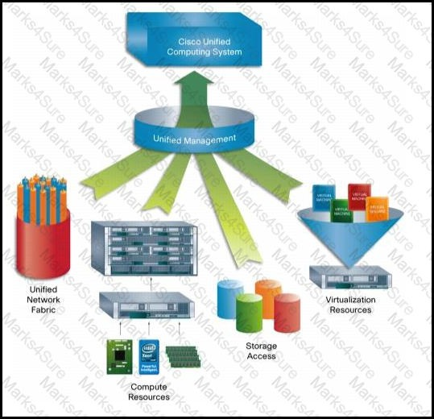

1. switch(config)# otv isis hello-interval 30

## Answer: A

Question #:143

Refer to the exhibit.

Which of these is an extension of the virtual machine abstraction that is applied to physical servers?

1. service profile
2. compute profile
3. organization profile
4. locale profile

Practice Test

Cisco - 300-180

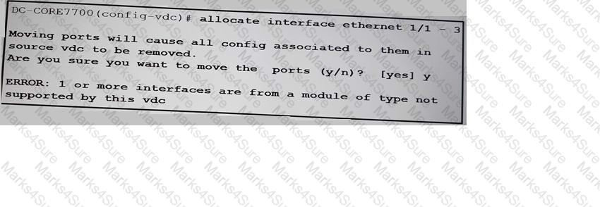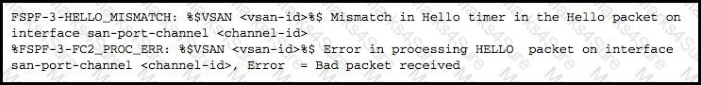

1. role profile

## Answer: A

Question #:144

Refer to the exhibit.

You install a new Cisco Nexus F3-Series module on a Nexus 7700 Series switch. When you attempt to allocate an interface from the module to a new VDC, an error occurs. Which issus could the error?

1. Cisco o Nexus F3-Series modules are unsupported in VDCs.
2. The limit-resource vlan minimum 16 maximum 4094 command missing.
3. The limit-resource module-type f3 command is missing.
4. Cisco Nexus f3-Series modules are unsupported on Nexus 7700 Series Switches.

## Answer: C

Question #:145

Refer to the exhibit.

Practice Test

Cisco - 300-180



VSAN traffic is not being routed through SAN fabric. Which action is helpful to resolve the problem?

1. Make sure that the FSPF hello interval value matches on both switches.
2. Change the FSPF hello timer back to the default of 5 seconds.
3. Make sure that the FSPF hello timers are different so that they do not compete.
4. Make sure that the FSPF dead timers are both set to 0.

## Answer: A

Question #:146

Refer to the exhibit.

You customer reports that the virtual machines operating on Host3 are not communicating with the external network .While troubleshooting you determine these facts:

* Host3 is a UCS blade chassis server connected to two fabric interconnect switches.
* The fabric interconnect switches are connected to the campus Cisco 6800 core switch.
* N1Kv is the virtual switch configured on the VMWARE hypervisor installed on Host3.
* port profile N1k-Uplink-Host3 is connecting Host3 virtual networks to the external network. Which reason is the cause of this problem?

1. port profile is the cause of this problem?
2. port aggregation mode under the N1k-Uplink-Host3 port must be changed to passive.
3. port aggregation mode under the N1k-uplink-Host 3 port profile must be changed to MAC pinning
4. port aggregation mode under the N1k-Uplink-Host3 must be removed.

## Answer: C

Question #:147

Practice Test



Cisco - 300-180

Practice Test



Cisco - 300-180

Practice Test

Cisco - 300-180



Cisco UCS users residing behind N5K2 are complaining about poor performance with a single LAN application in the data center. Which statement best explains what is wrong with N5K2?

1. Traffic balancing is based on the destination IP address.
2. Port channel members do not have equal bandwidths.
3. The trunk between the Nexus 5000 switches is filtering all VLANs.
4. E2/1 on N7010-C2 is not configured as a trunk for application traffic from N5K2.

## Answer: A

**Explanation**

Traffic balancing is based on the destination IP address

Use the “show port-channel load-balance” command to verify.

Question #:148

Refer to the exhibit.

Practice Test

Cisco - 300-180

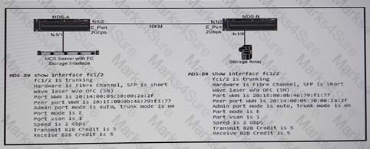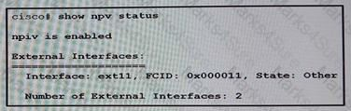

A customer has implemented dark fiber between two Cisco MDS SAN switches. After the network is put into production, the servers in site A experience poor performance when accessing the storage array in site B. While troubleshooting this issue, you discover the buffer credit applied on the interface that connects the MDS switches is incorrect. Which buffer credit value is need to optimize the performance of the storage array access

1. 9
2. 10
3. 11
4. 12

## Answer: D

Question #:149

Refer to the exhibit.

Which action resolves the problem?

1. Disabled NPIV on the switch.
2. Enabled port mode on the link to the NPV switch.
3. Configure the correct FC ID on the switch.
4. Change the VSAN in which the port is located.

Practice Test

Cisco - 300-180

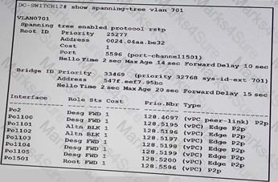

## Answer: B

Question #:150

Refer to the exhibit.

Which conditions can trigger on a Cisco Nexus device running FabricPath?

1. A switch connected to the Cisco Nexus device is running RSTP instead of STP.
2. A BPDU with bridge priority set to 61140 is received by the switch edge port.
3. The switch edge port in the STP domain is not configured as root.
4. VLAN is configured incorrectly on port-channel 100.

## Answer: C

Question #:151

Refer to the exhibit.

All the interfaces on the switch must forward traffic by using VLAN 701. Which action do you take?

1. Enable the vPC on port channel 1101 and port channel 1102.
2. Lower the switch priority such that it becomes the spanning tree root.
3. Increase the switch priority such that it becomes the spanning tree root.
4. Allow VLAN 701 on port channel 1101 and port channel 1102.

Practice Test

Cisco - 300-180



## Answer: B

Question #:152

You have a Cisco **APIC** that has a **VIC** 1225 adapter installed, Fabric discovery fails. You verify that the cabling is correct, but the LLDP fails, Which option is a possible cause of the failed fabric discovery?

1. Incorrect V|C adapter firmware version
2. Incorrect Cisco Nexus firmware version
3. an SFP transceiver issue
4. less than three APICs

## Answer: C

Question #:153

What is one requirement for running FabricPath on a Cisco Nexus 7000 Series switches?

1. You must have an F Series module
2. You must run NX-OS version 4.2 to run FabrciPath
3. ISSU needs to be disabled to run FabricPath
4. LAN_TRANSPORT_SERVICES_PKG license needs to be installed to run FabrciPath

## Answer: A

Question #:154

FHRP isolation between data center networks that are connected over an OTV network is a two-step process; the first prevents FHRP peering by filtering FHRP control packets across the overlay via a VLAN ACL. What is the second step?

1. Filter the FHRP MAC addresses that are being advertised by IS-IS.
2. Remove the FHRP VLAN from the OTV extend-vlan list.
3. Apply a VLAN to a route map that is applied to the OTV routing process.
4. Disable the auto-population of the OTV MAC address table.

Practice Test

Cisco - 300-180

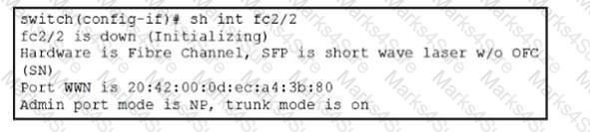

## Answer: A

Question #:155

Refer to the exhibit,

You configure a Cisco Nexus 5000 in NPV mode to enable multiple servers to log in over a single link to the NPV switch. Which option describes why the vfc interface is stuck on “initializing” state?

1. The load balancing is configured incorrectly on the Cisco Nexus 5000 switch.
2. The Version of code does not support the NPV feature.
3. The Cisco Nexus 5000 switch does not have "feature npv" enabled.
4. The upstream switch does not have "feature npiv" enabled.

## Answer: D

Question #:156

What is the correct configuration for interface Ethernet 1/1 of a Cisco Nexus 5000 Series Switch when it is a member of port channel 101 connected to FEX 101?

1. interface Ethernet1/1 switchport mode trunk switchport trunk native vlan 10

switchport trunk allowed vlan 20,30 fex associate 101

channel-group 101

1. interface Ethernet1/1 switchport mode fex-fabric

Practice Test

Cisco - 300-180



channel-group 101

1. interface Ethernet1/1 switchport mode access switchport access vlan 10 fex associate 101

channel-group 101

1. interface Ethernet1/1 switchport mode fex-fabric fex associate 101

channel-group 101

## Answer: D

Question #:157

Practice Test



Cisco - 300-180

Practice Test

Cisco - 300-180



The Cisco Nexus 2248 FEX has been added recently to the network via a vPC to the Nexus 5000 switches; however, connectivity is not yet operational. What is the problem with the configuration?

1. Both Nexus 5000 switches must associate to the same FEX number
2. Each Nexus 5000 should have its own FEX to support a straight-through topology.
3. The maximum number of links for pinning purposes should be increased to 2.
4. Ethernet1/18 must be configured without a port channel.

## Answer: D

Question #:158

Refer to the exhibit.

Practice Test

Cisco - 300-180

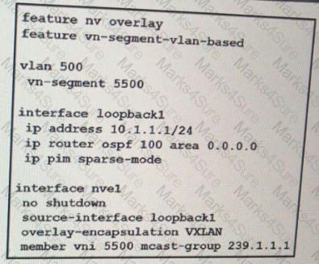

The VXLAN configuration fails. Which action do you take to resolve the issue?

1. Change the multicast address in the 232.0.0.0/8 range.
2. Change the mask of loopback1 to 255.255.255.255.
3. Use a transit interface as the source interface.
4. Enable dense mode on loopback1.

## Answer: B

Question #:159

Practice Test

Cisco - 300-180

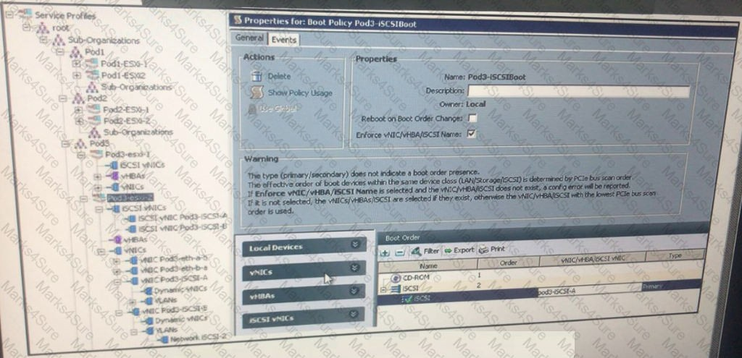

Refer to exhibit. After a boot policy is added, the profile stops working. Which option is a possible cause of the issue?

1. An iSCSI adapter is being used on top of the vNIC.
2. Both of the adapters from fabric A and fabric B must be specified.
3. The name of the adapter is incorrect.
4. The boot target does not exist.

## Answer: A

Question #:160

Which three statements are true regarding trunking on an ISL between two switches in order for the VSAN to be trunked? (Choose three.)

1. The VSAN must be defined on both switches.

Practice Test

Cisco - 300-180



1. The VSAN must be on the VSAN allowed list.
2. All VSANs that are being trunked must be using either enhanced or non-enhanced mode zoning, but not both.
3. IVR must be configured for Cisco Fabric Services.
4. The device alias database must successfully merge.
5. There cannot be any duplicate domain IDs within an individual VSAN.

## Answer: A B F

Question #:161

Refer to the exhibit.

Practice Test

Cisco - 300-180

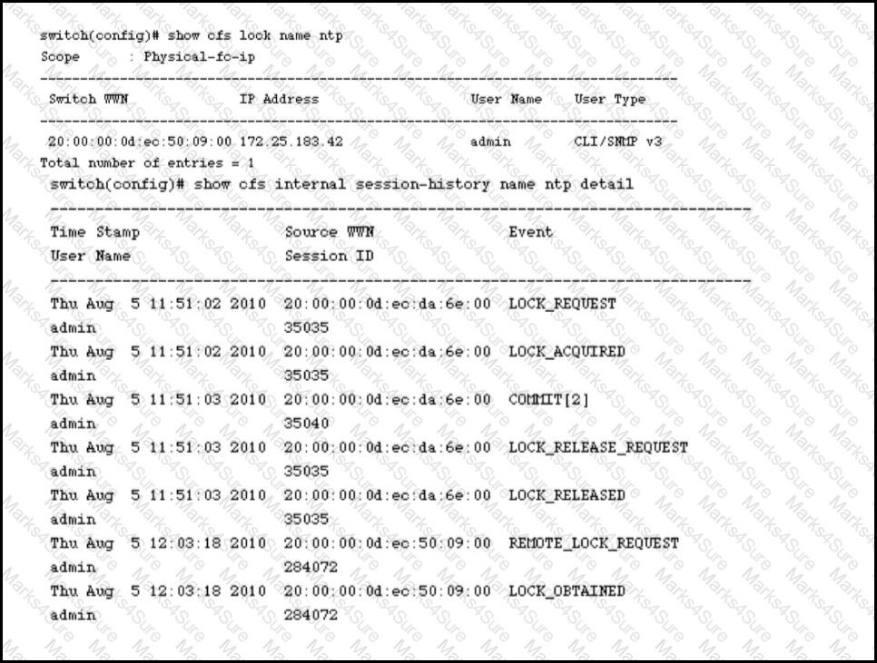

What command should you execute next in resolving a lock failure?

1. ntp execute
2. ntp commit
3. ntp lock
4. ntp help

Practice Test

Cisco - 300-180

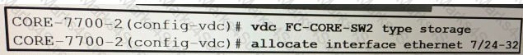

1. ntp detail

## Answer: B

Question #:162

An administrator wants to combine the advantages of a trunking F port and an F port channel. Which command on a Cisco MDS switch should be used to enable this?

1. enable port-channel
2. feature trunking-fport
3. feature fport-channel-trunk
4. port-channel trunk
5. feature fport-trunk

## Answer: C

Question #:163

In Cisco NX-OS releases prior to 5.2, how should the copp-system-p-policy policy be modified to change how the supervisor module is protected from DoS attacks?

1. Modify the policy map type control-plane copp-system-policy.
2. Open DCNM and modify the "copp-system-p-policy" policy object.
3. Re-run the setup utility and apply a new CoPP profile.
4. In Cisco NX-OS versions prior to 5.2, the CoPP system profile can only be modified from the CMP CLI.

## Answer: C

Question #:164

Refer to the exhibit.

Practice Test

Cisco - 300-180



Which two connectivity options for interfaces Ethernet 7/24-32 are valid?

1. FCoE interfaces that are shared among other VDCs
2. FCoE interfaces that connect to a storage array
3. Fibre Channel interfaces that connect to a storage array
4. Fibre Channel interfaces that are shared among other VDCs
5. FCoE interfaces that connect to a server

## Answer: B E

Question #:165

Which two commands will show all the OTV edge devices and their MAC addresses in all sites in the overlay? (Choose two.)

1. show otv adjacency overlay
2. show otv site
3. show otv vlan
4. show otv adjacency
5. show mac address-table

## Answer: A D

Question #:166

Refer to the exhibit.

Practice Test

Cisco - 300-180

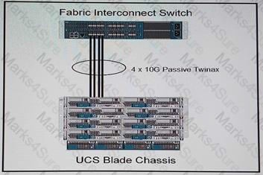

Your customer is migrating is their existing top-of-rack data center to a new location that uses an end-of-rack configuration. The customer requests a site survey prior to the migration. Which fact must you highlight in your survey that is required for a successful transition?

1. power source must be 240 volts only for blade chassis.
2. power source must be 240 volts only for fabric interconnect switches.
3. blade chassis using passive TWNAX cables must be placed within 5 meters of the end rack.
4. Blade chassis must not be fully equipped with blades when using and end-of-racksetup.

## Answer: C

Question #:167

Refer to the exhibit.

A zone merge failure occurs with the above error log. What is the problem?

1. Two switches have the same zone set name but different zone members.
2. Two switches have different zone names and different members.
3. Two switches have the same zone set name and the same members.

Practice Test

Cisco - 300-180

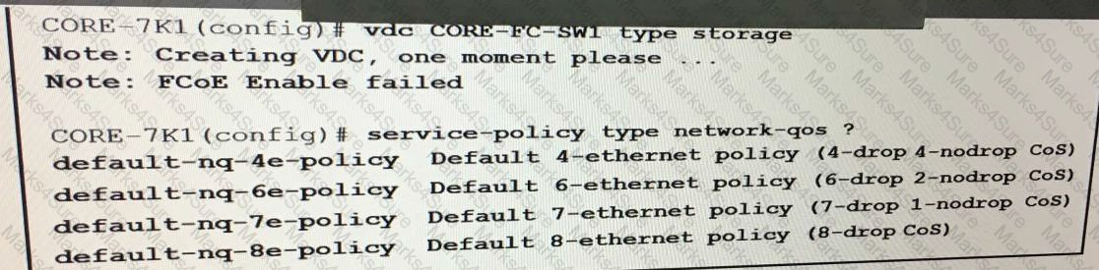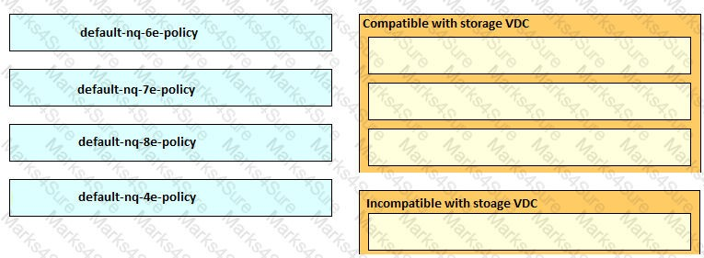

1. Two switches have different zone names.

## Answer: A

Question #:168

**Refer to Exhibit.**

You are configuring a FCoE VDC on a Cisco Nexus 7000 Series Switch. You are required to identify compatible QoS policies for the FCoE VDC. Drag and drop the QoS Policy names from the left onto the correct compatibility categories on the right.

## Answer: